# Oscilloscope Lab

# Seth Ricks

# ECEN 350

# Brother Swenson

10/3/2025

# ECEN 350 - Oscilloscope Lab (50 points)

(jas, Oscilloscope Lab.docx, 10/03/2025)

**Note: You can work in pairs if desired on this lab, although no three person teams are allowed. Submit an electronic version of a lab report to receive credit for doing this lab.** The goal of your **lab report is to provide sufficient documentation so that the lab can be repeated if necessary**. Therefore, simply add to this document to arrive at your lab report, as all of the explanatory text, procedures, and Discussion and Conclusion questions contained in this document are required for a complete lab report. So, for your lab report, **add a cover page that includes name or names, class and name of the lab. Also add in your results, and answers to the Discussion and Conclusions questions to the existing lab document**. While you are to share all **Procedure** items with your lab partner if you worked in a pair, your **Discussion and Conclusions** section is to be uniquely yours and not a copy of your lab partners. See the grading rubric at the end of this document for more details.

**Purpose:** For many Electrical Engineers an oscilloscope is their most valuable piece of test equipment. The purpose of this lab is to become better acquainted with the workings and limitations of oscilloscopes and oscilloscope probes.

**Parts and Equipment:**

1 - 10 MΩ Resistor

1 - VirtualBench Measurement System and Computer

2 - 1X/10X Probes for the VirtualBench Mixed Signal Oscilloscope (MSO).

1 – BNC (Bayonet Neill-Concelman) to alligator or micro-grabber cable for VirtualBench FGEN output.

**Oscilloscope Basics**

If you don’t know the difference between a 1X and 10X probe, or what a waveform trigger is, then please read the following tutorial information before proceeding.

Oscilloscopes measure and display voltage versus time, with the voltage on the y-axis and time on the x-axis. So, while oscilloscopes can measure and display non-changing, i.e., DC voltages, they are most useful in measuring and displaying time varying voltages. The VirtualBench oscilloscope offers two input channels, meaning that two different voltage waveforms can be viewed simultaneously. While the amplitude of each waveform can be adjusted independently, both waveforms share the same time axis. The VirtualBench oscilloscope inputs use a BNC (Bayonet Neill-Concelman) type input connector that is to be connected to the BNC end of an oscilloscope probe. The BNC end of the oscilloscope probe fits over the mating BNC input connector on the oscilloscope and is to be twisted to lock and unlock the probe from the oscilloscope. **Figure 1** illustrates an oscilloscope probe, which offers a probe tip with a spring-loaded clip lead to be connected to the circuit node to be measured, with the ground connection provided by the alligator ground clip. The oscilloscope probe ground clip is connected to earth 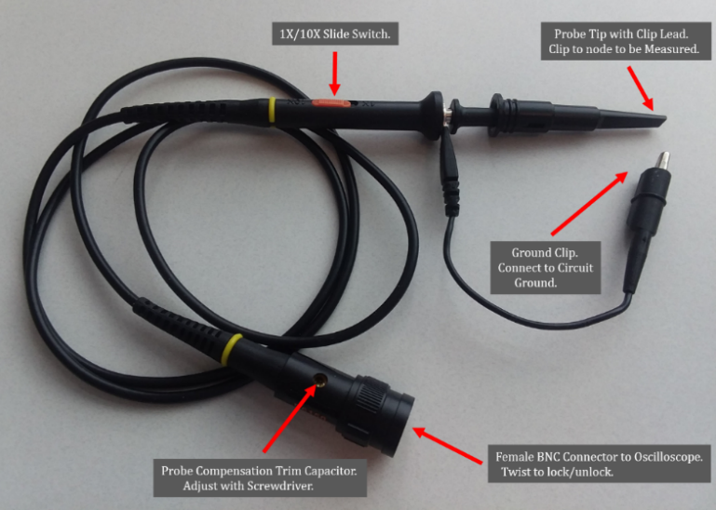ground through the oscilloscope AC power cord, meaning that connecting the alligator ground clip to a circuit node results in that node being shorted to earth ground. Also shown in **Figure 1** is a 1X/10X slide switch, which configures the probe for either 1X, i.e. , no attenuation, or 10X, a factor of 10 attenuation of the input signal. Hence, a 10X probe can measure larger input voltages than a 1X probe.

**Figure 1**: 1X/10X Oscilloscope Probe.

A 10X oscilloscope probe attenuation is the most common setting for general purpose measurements. A 10X probe provides a 10 MΩ resistance/impedance to ground along with significantly reduced capacitance, compared to a 1X probe offering 1 MΩ resistance/impedance to ground and non-negligible capacitance. The result is that the 10X probe affects (loads) the circuit to be measured appreciably less than a 1X probe, which is important for medium and high-speed voltage measurements. **Figure 2** illustrates an equivalent circuit for a typical 10X oscilloscope probe and oscilloscope input.

**Figure 2**: Typical 10X Oscilloscope Probe Schematic.

The 10 MΩ resistance/impedance to ground for a 10X probe is formed by a 9 MΩ resistor in the probe connected in series with a 1 MΩ resistor to ground inside the oscilloscope, as illustrated in **Figure 2**. The 9 MΩ and 1 MΩ resistors form a 10:1 voltage divider, resulting in a factor of 10 attenuation. For medium and high-speed voltage measurements the reduced resistive and capacitive loading of a 10X probe is often more important than the loss of signal amplitude by a factor of 10. However, the 1X probe setting is beneficial when measuring small-amplitude low-frequency signals. It should be noted that in addition to the slide switch on the oscilloscope probe, the oscilloscope itself must be configured for either a 1X or 10X probe for the displayed voltage amplitude to be correct. The adjustable compensation capacitor, CComp illustrated in **Figure 2**, provides adjustable frequency compensation, which helps mitigate measurement overshoot and undershoot errors associated with rapidly changing voltages.

Most oscilloscopes, including the VirtualBench oscilloscope, provide a square wave oscillator output for a quick check to see if the probe compensation is adjusted correctly. A correctly compensated probe will display a flat-topped waveform, as shown in the top waveform of **Figure 3** below, when connected to an ideal square wave voltage. The middle and bottom waveforms of **Figure 3**, illustrate waveform undershoot and overshoot associated with an oscilloscope probe that needs adjustment of the compensation capacitor.

**Figure 3**:Oscilloscope Probe Compensation Waveforms

[**National Instruments VirtualBench**](http://www.ni.com/virtualbench/what-is/) is illustrated in **Figure 4** and is a combined instrument that includes a 2-Channel Mixed Signal Oscilloscope (MSO), Function Generator (FGEN), programmable DC Power Supplies (PWS), eight general purpose Digital I/O ports (DIO), along with a Digital Multimeter (DMM). The VirtualBench instrument interfaces to a computer and VirtualBench software provides the necessary user interface to measure and control the various functions mentioned. Windows 11 computers can sometimes fail to install the correct drivers when connecting to the Virtual Bench machines. When this happens, the drivers can be installed manually to successfully connect to the Virtual Bench machines. The following document outlines the procedure to manually install the Virtual Bench drivers. [Manual VirtualBench Driver Installation](https://content.byui.edu/file/f8b44dda-2a96-41cd-8a40-6a1483b29dc2/1/Labs/Installing%20Virtual%20Bench%20Drivers%20For%20Windows%2011.docx).

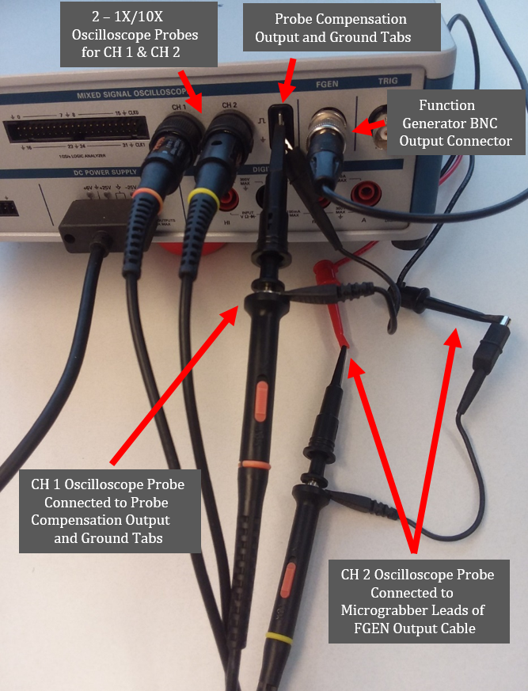

**Figure 4**: National Instrument VirtualBench with 2 - Oscilloscope Probes along with the Function Generator (FGEN) Output.

The VirtualBench Oscilloscope User Interface Screen with Channel 1 (red) connected to a 1 kHz sine wave with 5 V peak-to-peak output amplitude is illustrated in **Figure 5** below. Several automatic waveform measurements are available for the oscilloscope, controlled by means of the Waveform Measurement Icon illustrated below in **Figure 5**. Two waveform cursors are also available, controlled by the Waveform Cursor Icon, illustrated below in **Figure 5**.

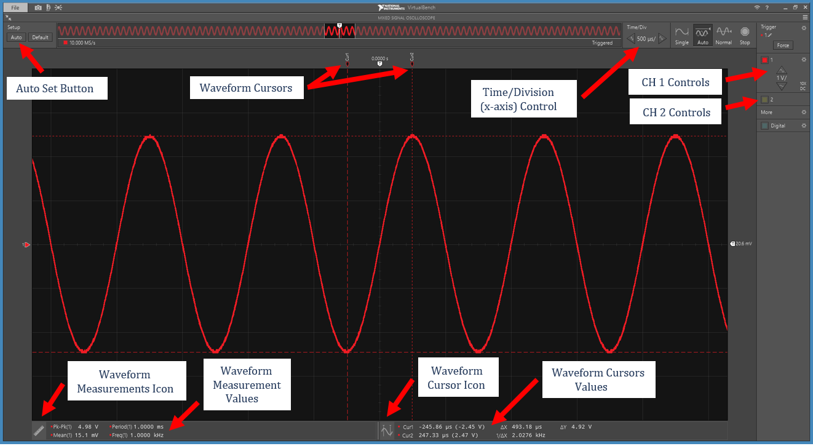

**Figure 5**: VirtualBench Oscilloscope User Interface Pane Example.

The **Auto** button illustrated in the upper left-hand corner of the screen in **Figure 5**, provides for automatic waveform adjustment. The **Auto** setup button can be useful whenever you lose track of the waveform being measured or connect the probes to a new waveform, as it is intended to find and display the desired waveform for you. However, the Auto setup button also is prone to home in on small amplitude, high-frequency noise, rather than the signal of interest. When using DC coupling large vertical DC offset voltages may also be added to better view the small amplitude noise. So be careful when using the Auto setup button, as it may find an unwanted small amplitude high-frequency noise signal rather than the signal of interest. If you don’t see the signal of interest after invoking the Auto setup, check the Time/Div (x-axis) setting to make sure it is not set to one of the ns (nanoseconds) per division setting, since practical signals of interest should require Time/Div settings in the μs (microseconds) per division or greater. Note: The Auto setup button is different than the Auto trigger mode. In **Auto** trigger mode, the oscilloscope automatically triggers and displays the captured waveform after waiting a certain time for a valid trigger to occur, providing some user feedback when the waveform to be measured does not provide a valid trigger event.

In its simplest form, a waveform trigger is a voltage level that provides a reference point for the waveform display. The VirtualBench oscilloscope acquires a sizeable portion of waveform voltage versus time data, then displays the results utilizing a waveform reference point determined by the waveform trigger. This acquisition and display process is repeated over and over, resulting in periodic waveforms appearing stationary when properly triggered. So, oscilloscope waveform triggering provides for periodic (repeating) waveforms to look stationary, which is useful for waveform viewing and analysis. Periodic signals with non-negligible random voltage variations (noise) often appear to jitter back and forth on an oscilloscope screen, because the noise causes the trigger reference point to occur at slightly different portions of the waveform each time the waveform is displayed. A Noise Reject triggering Hysteresis option, available in the **Trigger Settings** pane, helps minimize waveform jitter on noisy signals by noise filtering.

Oscilloscopes provide voltage triggering on either rising (increasing) of falling (decreasing) waveform voltages, referred to as Rising or Falling edge triggering. The **Auto** setup button of the VirtualBench oscilloscope sets the trigger conditions for a given waveform, which is sufficient for most measurements, although sometimes specialized triggering conditions are desired, requiring the user to manually adjust the triggering using the Trigger menu.

The VirtualBench oscilloscope offers **Auto**, **Normal** and **Single** triggering modes, along with a Stop mode that stops waveform triggering to freeze the current waveform on the screen. In the **Normal** trigger mode, the oscilloscope refreshes a displayed waveform after a valid trigger occurs. If a valid trigger does not occur, then the display never updates. **Auto** trigger comes to the rescue in these circumstances. In **Auto** trigger mode, the oscilloscope automatically triggers and displays the captured waveform after waiting a certain time for a valid trigger to occur, providing some user feedback regarding the waveform to be measured. The **Auto** trigger mode is the default triggering mode for the VirtualBench oscilloscopes. The **Auto** button illustrated in the upper left-hand corner of the screen in **Figure 5**, sets the oscilloscope triggering to **Auto** and provides for automatic adjustment of the amplitude and time scales to better view the waveform.

**Single** triggering is useful for capturing and then freezing on the screen a one-time event. If you try to view a one-time event using **Auto** triggering, the oscilloscope will display the event upon receiving a valid trigger but then refresh the display with a new waveform upon the next trigger. So, each of the three VirtualBench triggering modes have their place in waveform measurements, as does the Stop triggering mode when one does not want the currently displayed waveform to be replaced by a new waveform capture.

When making oscilloscopes measurements, sometimes only the changing portion of waveforms are of interest, and not the unchanging or DC portion. Since capacitors block DC voltage while passing AC voltages, inserting a capacitor in series with the input signal blocks the DC portion of a waveform while passing the AC portion. Oscilloscopes have a built in DC blocking capacitor on each input that can be bypassed or inserted in series with the signal under user control, referred to as input coupling. **DC input coupling** provides the entire waveform, i.e., both the changing and constant portions, while **AC input coupling** blocks the constant DC portion leaving only the time varying portion of the waveform. Each of the two input channels of the VirtualBench oscilloscope offers DC or AC coupling under user control.

**Figure 6** illustrates a 5 V peak-to-peak sinewave with a 2.5 V DC offset voltage that is measured with both Channel 1 (red) and Channel 2 (yellow) of the VirtualBench oscilloscope. In **Figure 6**, oscilloscope Channel 1 utilizes DC Input Coupling while Channel 2 utilizes AC Input Coupling. The mean (average) value of the voltage associated with Channel 1 is approximately 2.5 V, which equals the DC offset voltage of the input signal, while the mean (average) value of the voltage associated with Channel 2 is approximately 0 V. **Figure 6** also indicates the amplitude and time scales of the displayed waveform, the location of the 0 V waveform amplitude reference, along with the selected Automatic Waveform Measurements for this particular measurement example.

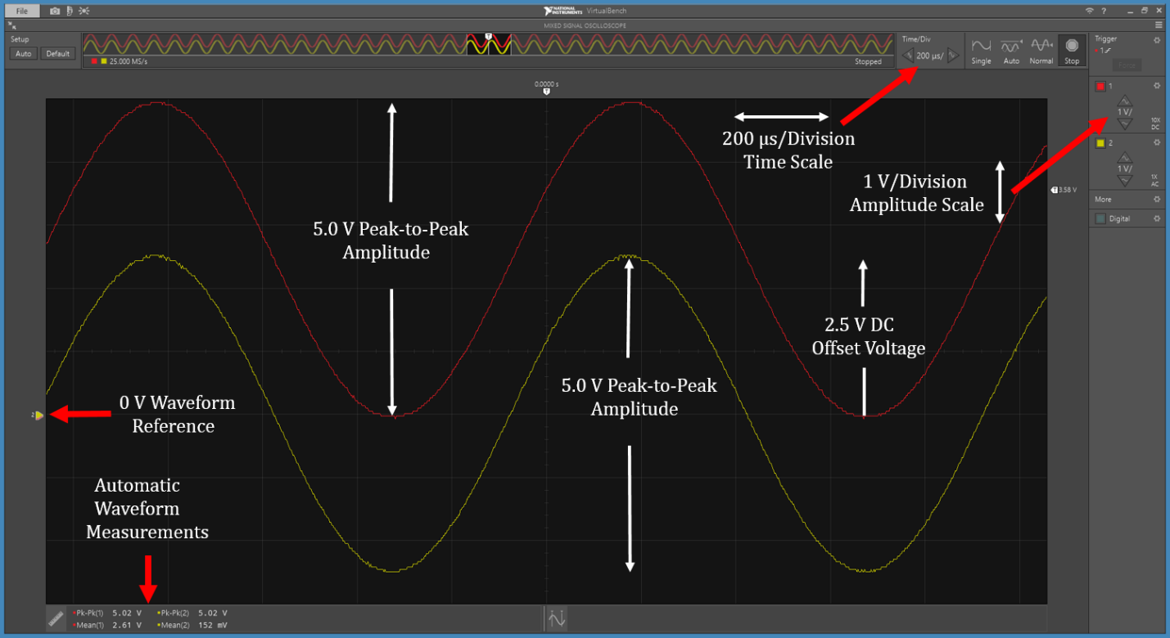

**Figure 6**: DC and AC coupling of a 5 V peak-to-peak Sine Wave Input Signal with a 2.5 V DC Offset.

**Oscilloscope Summary**

* While oscilloscopes can be used to measure signals that do not vary with time, they are most useful for measuring and providing visualization of time varying signals.
* A 10X probe configuration is the most common and used to minimize the loading of the circuit to be measured, which is helpful for medium and high-speed circuits.
* The 10X/1X probe setting selected on the probe slide switch must match the associated oscilloscope input channel configuration for proper display of voltage amplitudes.
* The oscilloscope probe ground clip is connected to earth ground through the AC power cord of oscilloscope, resulting in the ground clip providing a short circuit to earth ground when clipped to a circuit node.
* Twist to lock and unlock the BNC type mating connectors for oscilloscope probes and the FGEN connection cable.
* Oscilloscopes offer both **DC and AC input coupling.** **DC input coupling** provides the entire waveform being measured, i.e., both the changing and constant portions, while **AC input coupling** blocks the constant DC portion, leaving only the time varying portion of the waveform.
* **Auto**, **Normal** and **Single** triggering, along with **Stop** triggering each provide helpful ways to control the updating of displayed waveforms.

The **Auto** button located in the upper left-hand corner of the VirtualBench user interface screen can provide helpful automatic waveform adjustment when signals are not displayed correctly on the oscilloscope. However, for measuring DC or low-frequency signals, the automatic waveform adjustment will often result in an unwanted amplified view of high-frequency noise associated with a DC signal. The oscilloscope can view small noise voltages associated with much larger DC voltages by incorporating a vertical DC offset voltage and amplifying the resulting signal, which is undesirable for most DC or low-frequency measurements. Hence, manually adjusting as follows may be best when measuring DC or slowly varying signals: make sure the triggering is set to **Auto** trigger when measuring DC or slowly changing signals, as these signals have no valid trigger events. Zero out the vertical DC offset voltage in the channel settings menu and adjust/increase the vertical scale to a value that best fits the signal to be measured, such as 1, 2 or 5 V/division. Also adjust the horizontal time base setting to 20 ms/division or slower.

**Procedure:**

**Part 1 – Probes and Probe Compensation**

1. Connect the oscilloscope probe with the red marking bands to Channel 1 (CH 1) and the oscilloscope probe with the yellow marking bands to Channel 2 (CH 2) on the VirtualBench CH 1 and CH 2 oscilloscope BNC connectors, as illustrated in **Figure 4** from the tutorial section. Make sure the slide switches at the probe tip end of the oscilloscope probes are set to 10X versus 1X.
2. Start up the VirtualBench interface software and for the CH 1 and CH2 settings

make sure that both are set for DC coupling and 10X probe attenuation.

1. Connect the CH 1 (red) probe tip to the **PROBE COMPENSATION Output**and the ground clip to the **PROBE COMPENSATION GROUND TAB**of the VirtualBench as illustrated in **Figure 4** from the tutorial section.
2. Click on the **AUTO** button in the upper left corner of the VirtualBench user interface screen, which automatically adjusts the vertical scale, horizontal scale and trigger settings for a useful waveform display. Within a few seconds, you should see a square wave displayed for the CH 1 (red) trace.
3. Adjust the probe compensation trim capacitor with a small standard screwdriver if the displayed square wave has noticeable undershoot or overshoot as illustrated in **Figure 3** from the tutorial section.
4. Toggle the 10X/1X slide switch on the probe body of the CH 1 probe back and forth from 10X to 1X while observing changes to the waveform displayed on the User Interface Screen.
5. On the VirtualBench User Interface Screen, toggle the CH 1 settings back and forth from 10X to 1X again observing changes to the waveform displayed on the User Interface Screen.
6. As your observations confirm, the oscilloscope probe slide switch setting must be matched to the User Interface Screen channel setting, with a 10X slide switch and oscilloscope channel setting being the most common.
7. Check the probe compensation on the CH 2 (Yellow) probe also, adjusting the probe compensation trim capacitor if necessary.

**Part 2 – Oscilloscope DC Voltage Measurement**

1. 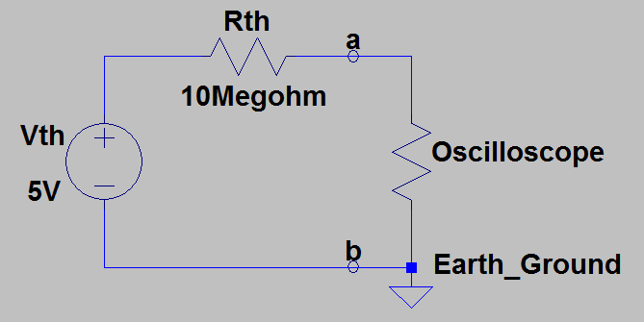Construct the Thevenin equivalent circuit illustrated in **Figure 7**. This circuit represents a voltage source with a high (10 MΩ) output resistance/impedance. For the supply voltage Vth in **Figure 7**, use one of the adjustable VirtualBench power supplies set to 5.000 V.

**Figure 7:** Thevenin Equivalent Circuit with 5 V Vth and 10 MΩ Rth.

1. Set oscilloscope CH 1 up for a 1X probe using DC coupling. Connect the CH 1 probe to measure the DC voltage across the a and b terminals as illustrated in **Figure 7**. Make sure that **Auto** triggering is employed and do not use automatic waveform adjustment, as that will likely result in an unwanted DC offset and amplified vertical amplitude in the oscilloscopes attempt to find small high-frequency noise voltages associated with a DC signal. However, for measuring DC or low-frequency signals, the automatic waveform adjustment will often result in an unwanted amplified view of high-frequency noise associated with a DC signal. Hence, manual oscilloscope adjustments are recommended for measuring DC signals.
2. Adjust the displayed DC waveform so that there are several vertical divisions between the 0 V waveform reference, and the maximum waveform level for good measurement resolution as illustrated in **Figure 8** below.
3. Using the waveform cursors, set the type to **Voltage** and record the DC voltage observed from the CH 1 oscilloscope probe in the first column of **Table 1**.

**Figure 8**: Oscilloscope DC Voltage Measurement Using Waveform Cursors.

1. Next change oscilloscope CH 1 for a 10X probe and again measure the DC voltage across the a and b terminals, recording your measured results in the second column of **Table 1**. Be sure to include units, either by adding them to the column label or to each value. (6 Points total, 3 points each.)

**Table 1**: Measured Results from Thevenin Equivalent Circuit of **Figure 7**.

|  |  |
| --- | --- |
| Measured Vab Voltage for 1X Probe Measurement | Measured Vab Voltage for 10X Probe Measurement |
| 414 mV | 2.40 V |

**Part 3 – Waveform Measurements**

1. Configure the VirtualBench Function Generator (FGEN) to output a 1 kHz sine wave with a 5.0 V peak-to-peak output voltage and 0 V DC Offset.
2. Configure oscilloscope CH 1 for a 10X probe and **DC coupling** and connect the CH 1 probe to the FGEN output. Invoke the **Auto** Setup button in the upper left corner to automatically optimize the waveform display.
3. Add the following Waveform Measurements to CH 1: **Amplitude**, **RMS**, **Peak-to-peak**, **Mean**, **Period** and **Frequency**.
4. Also enable and attach both waveform cursors to CH 1 as type **Track**, i.e., tracking both voltage and time simultaneously.
5. Position the waveform cursors 1/2 cycle apart with one cursor on a waveform peak and the other cursor on a waveform valley, providing both period and peak-to-peak amplitude information from the tracking cursors.
6. Your resulting oscilloscope waveform and selected Waveform Measurements should look like the screen capture shown in **Figure 9**.
7. Save a copy of your resultant waveform, including the numerical values for the 6 Waveform Measurements to be used later. Note: Manually record the numerical values for any of the 6 Waveform Measurements that are not visible in your screen capture, as some may be truncated on small laptop screens. Replace the image shown in **Figure 9** below with your version. (8 points total.)

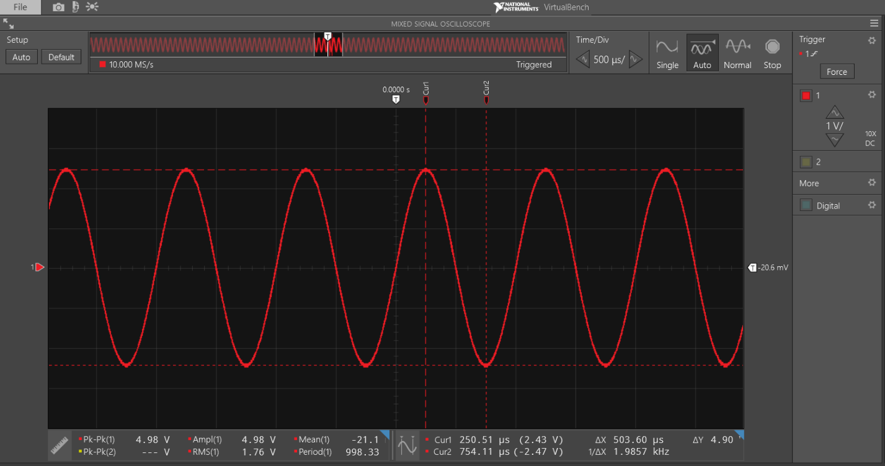

Seth Ricks

**Figure 9:** VirtualBench Display for Oscilloscope Measurement of 1 kHz, 5 V Peak-to-Peak Sine Wave from FGEN.

**Part 4 – Waveform Triggering**

1. The VirtualBench oscilloscope waveform shown below in **Figure 10** illustrates the on-screen **Trigger Time Reference** and the **Trigger Voltage Level** markers. The Trigger Voltage Level can either be adjusted by dragging the trigger marker with the mouse or by entering the number in the **Trigger Settings** pane.

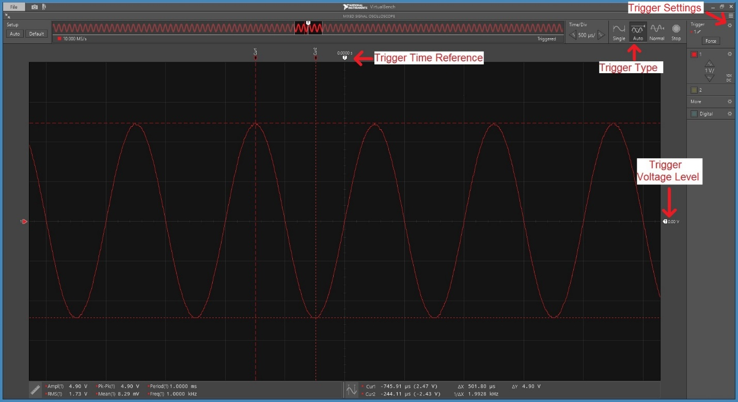

**Figure 10:** VirtualBench Display for Oscilloscope Measurement Illustrating Trigger Time Reference and Trigger Voltage Level Markers.

1. Go back to measuring a 1 kHz, 5 V peak-to-peak sine wave with 0 V DC Offset on CH 1. In the **Trigger Settings** pane, toggle back-and-forth the trigger **Edge Direction** from **Rising** (positive) to **Falling** (negative) while observing the waveform crossing the center graticule (grid) of the display.
2. Next with trigger type set to **Auto**, increase the **Trigger Voltage Level** to approximately 3 V, to be above the peak value of the sine wave, and observe the resulting waveform.
3. Next reduce the **Trigger Voltage Level** to near 0 V and set the trigger type to **Normal**.
4. Again, increase the **Trigger Voltage Level** to approximately 3 V, to be above the peak value of the sine wave, and observe the displayed waveform.
5. Next add a 1 V DC Offset to the FGEN sine wave output so that the sine wave peak exceeds the 3 V trigger level and observe what happens to the displayed waveform.

**Part 5 – DC and AC Input Coupling**

1. Set the FGEN to output a 1 kHz, 5 V peak-to-peak sine wave with 0 V DC Offset on CH 1 with **Auto** triggering, a 10X probe and DC Coupling, invoking the **Auto** Setup option.
2. Set the CH 1 vertical scale to 2 V/division.
3. Change the DC Offset voltage on the FGEN output from 0 V to 5 V, then to -5 V, then back to 0 V, observing the waveform display.
4. Change the CH 1 setting from DC to AC coupling, which refers to the input signal coupling to the oscilloscope.
5. Change the DC Offset voltage on the FGEN output from 5 V to -5 V, then back to 0 V, observing the waveform display with AC coupling.
6. Change the CH 1 coupling setting to DC coupling,
7. With the CH 1 vertical resolution set to 500 mV/division, set the FGEN output to a 1 kHz sine wave with an amplitude of 0.05 V peak-to-peak, and then add a 1 V DC Offset voltage, observing the resulting waveform.
8. Change the CH 1 input coupling from DC to AC, then adjust the vertical scale to 100 mV/division. In the Trigger settings invoke Noise Reject, which should allow you to trigger on this relatively small AC signal riding atop a large DC offset voltage.
9. Next change the probe slide switch and channel configuration from 10X to 1X and adjust the vertical scale to 10 mV/division. This is the most sensitive vertical scale available on the VirtualBench oscilloscope and will be needed for a good ripple rejection measurement for the upcoming Power Supply Project.
10. Change the probe slide switch and channel configuration back from 1X to 10X, as this is the most common setting.
11. Done.

**Discussion and Conclusions Questions:** (For the following questions use your own words along with complete sentences. Points are to be deducted for AI generated answers.)

1. Using the Thevenin Equivalent circuit of **Figure 7**, along with your measured results from **Table 1**, calculate the oscilloscope input resistance/impedance you observed for DC voltage measurements with the 1X and 10X oscilloscope probes. Rather than specifying input resistance, oscilloscope manufacturers specify input impedance, although for low-frequency measurements with DC coupling the input impedance essentially equals the input resistance. (8 points total, 4 points each.)

Zin_1X = 0.9 MΩ

Zin_10X = 9.2 MΩ

1. Input impedance specifications for oscilloscopes including probes are usually rounded up to the nearest Megohm. Based on your low-frequency input impedance calculations for the 1X and 10X probe measurements, list below your recommended input impedance specifications for both the 1X and 10X probe measurements, rounded to the nearest Megohm. (2 points.)

**Table 2**: Specified Input Impedance:

|  |  |
| --- | --- |
| 1X Probe with VirtualBench | 10X Probe with VirtualBench |
| 1 MΩ | 10 MΩ |

1. Describe the benefits of a 10X oscilloscope probe as compared to a 1X probe. (2 Points.)

A large input impedance means that the probe draws very little circuit, so the measurement we want to make isn’t disturbed.

1. Describe the benefits of a 1X oscilloscope probe as compared to a 10X oscilloscope probe. (2 Points.)

The smaller input impedance in the probe means that the original signal is seen in full. This means that smaller signals can be seen more easily. But there is also the downside of the probe drawing a larger current because of the smaller input impedance.

1. Calculate and include below the theoretical RMS value for a 5 V Peak-to-Peak, zero mean sine wave. Also include below your measured **RMS** value from **Figure 9** of Part 3. (2 Points.)

Vrms_calc = V

Vrms_meas = 1.76 V

1. Explain the differences between **Auto** and **Norma**l trigger modes. (6 Points, 3 points each.)

The Auto trigger infers the range of the input signal for us, while the normal trigger is for when we already know the signal’s properties.

1. When trying to display an unfamiliar signal on an oscilloscope is **Auto** or **Normal** triggering more functional and why? (2 Points.)

The Auto trigger makes more sense for this scenario. This is because the signal has an unknown amplitude and type. If we do the normal triggering setting, and the setting is out of the range of the actual signal, then the oscilloscope will print the waveform when it times out, and it will be very jittery and unpredictable. Doing Auto means that the oscilloscope will find the triggering range for us, so that we will not have that problem.

1. Explain the differences between **AC** and **DC** input coupling of the signal to be measured. (4 Points.)

The difference between AC and DC input coupling is that DC considers DC offset, while AC does not. If we have a sinusoidal wave with no DC offset, then AC and DC coupling will result in the same displayed waveform. But if the wave has an added DC offset, AC will display the same wave as before, while DC will display the waveform transformed in the upward direction by the DC offset value.

1. When attempting to characterize a small voltage ripple superimposed on a relatively large DC voltage with an oscilloscope, would you choose AC or DC coupling and why?

(2 Points.)

If the DC voltage is quite large, it would probably be better to choose AC coupling. This is so that the voltage line with the ripple will be plotted around 0 volts, so it would be easier to find and see. If we chose DC coupling, we would have to go find the voltage line. If it is quite large, this could be an unnecessary and tedious step.

**Oscilloscope Lab Grading Rubric:** **Submit an electronic version of a lab report to receive credit for doing this lab.** The goal of your **lab report is to provide sufficient documentation so that the lab can be repeated if necessary**. Therefore, simply add to this document to arrive at your lab report, as all the explanatory text, procedures, and Discussion and Conclusion questions contained in this document are required for a complete lab report. So, for your lab report, **add a cover page that includes name or names, class and name of the lab. Also add in your results, and answers to the Discussion and Conclusions questions to the existing lab document**. While you are to share all **Procedure** items with your lab partner if you worked in a pair, your **Discussion and Conclusions** section is to be uniquely yours and not a copy of your lab partners.

|  |  |
| --- | --- |
| **Lab Report Item** | **Points** |
| Cover Page | 2 |
| Reasonable **Table 1** values with units. (3 points per entry, -0.25 points for each missing unit) | 6 |
| **Figure 9** Screen Capture – (8 points total, 1 point each for reasonable values for the 6 displayed automatic measurements, 1 point each for reasonable cursor positions and values) | 8 |
| Discussion and Conclusions | 30 |
| Grammar and Professionalism | 4 |
|  |  |
| **Total** | 50 |

Please give feedback on errors you find in this document.